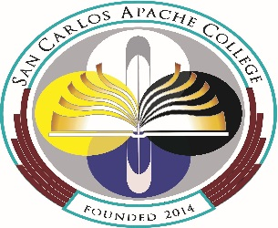

Syllabus: Prefix and course name

Course Information
Course Prefix/Number:  Semester:  Class Days/Times: | Credit Hours:  Course Title:  Room:

Instructor Information:  Name: | Phone/Voice Mail:  E-mail:  Office location:  Office hours:

Course Description:

Course Objectives:

During this course students will ………..

Student Learning Outcomes (SLOs): (Three to Six)

After completion of the course students will be able to <<action verb>> <<something>> ……

Course Structure:
Organization, learning activities, instructions, expectations, and must have at least one learning activity for each objective, but may have more than one.

Texts and Materials: (list text(s), and materials students will need)

Evaluation and Grading & Assignments: (information on how the course grade will be determined; details regarding assignments, exams, projects with due dates and any instructions for work. Make sure that you have one or more learning activities in the calendar/schedule that address each outcome. An activity can address more than one outcome.)

Apache Cultural Component: San Carlos Apache College is in the process of developing culturally relevant curriculum and coursework in Apache history, culture, and language. Student and community feedback will guide this process. All SCAC instructors will find ways to incorporate culturally relevant topics and materials into their courses as appropriate.

Policies and expectations- minimally address attendance, participation, tardiness, academic integrity/plagiarism, absences, missed homework or exams, late assignments, student behavior, official ADA statement, and any other policies you have for your course.

Course Outline:

DISCLAIMER: This syllabus is designed to evolve and change throughout the semester based on class progress and interests. You will be notified of any changes as they occur.

Approved:

